Experiment 3: Develop a Property Buying/Rental Application for Chennai as SaaS
Aim
To develop a cloud-based Property Buying and Rental application for Chennai using Zoho Creator.
Software Used
- Zoho Creator
- Deluge Workflow
- Web Browser
Algorithm
- Create Customer Registration form.
- Create Property Owner Registration form.
- Create Property Listing form.
- Create Property Search form.
- Create Property Inquiry form.
- Allow customers to search properties.
- Record inquiries and site visits.
- Generate reports for available properties.
Output:

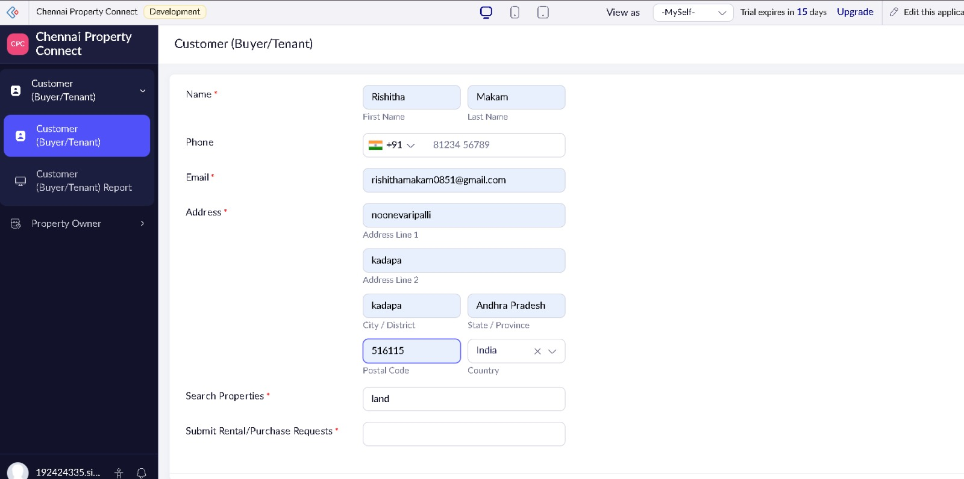

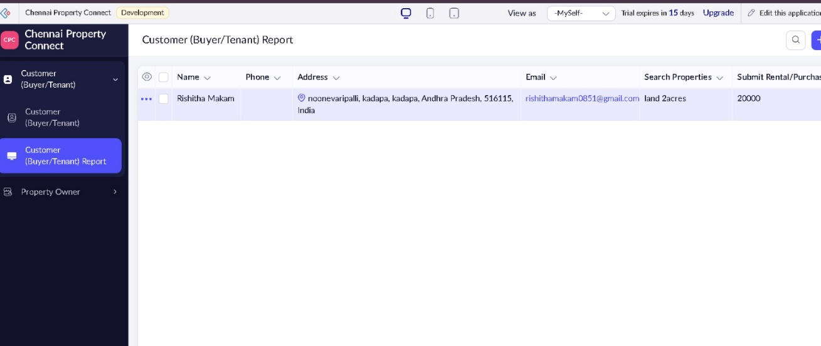

Result
A SaaS Property Buying/Rental application was successfully developed for managing property listings and customer inquiries in Chennai.

